# 3- PHASE RECTIFIER MODEL

3-phase rectifier takes 3-phase AC input and convert it to DC. The circuit schematic of rectifier is shown at Figure 1.

As can be seen at the circuit schematic, uncontrolled(diode) bridge rectifier is used. The bridge rectifier has 6 diodes, and each two diodes which are called Top and Bottom diode belong to one phases. Diodes conducts with respect to voltage between cathode and anode leg of themselves. If the voltage of input side of a leg is bigger than voltage of output side of bridge rectifier, the diodes on the legs pass to conduction.

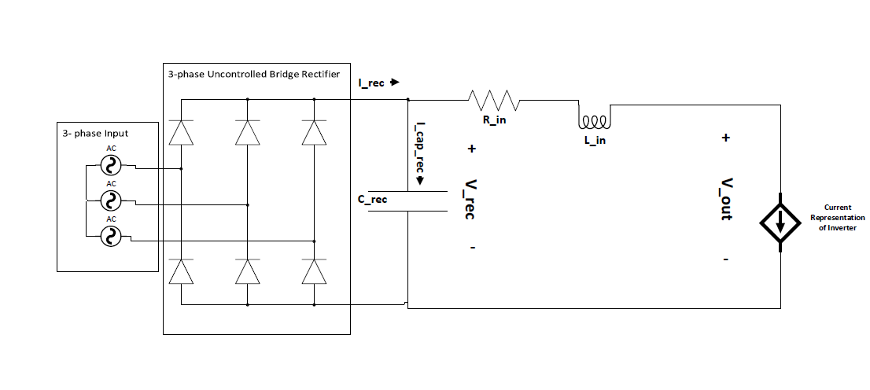

Figure 1 Three Phase Rectifier

After bridge rectifier, output voltage is 6-pulse voltage follows the line-to-line voltage for 3-phases as shown Figure 2.

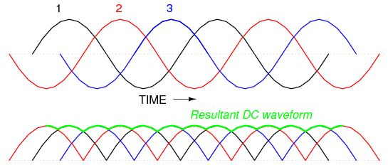

Figure 2 Input and Output Waveform of Three Phase Bridge

The waveform is filtered by DC-bus capacitor at output. The capacitor is in range of 1-10 mFarad to filter low harmonic components. However, the current drawn by load and capacitor value changes the output waveform of bridge rectifier. The bridge rectifier cannot be thought as linear circuit. The output waveform depends on current drawn and the voltage at output. There are two condition which are output voltage is bigger than input and vice versa.

Figure 3 shows the output voltage with capacitor.

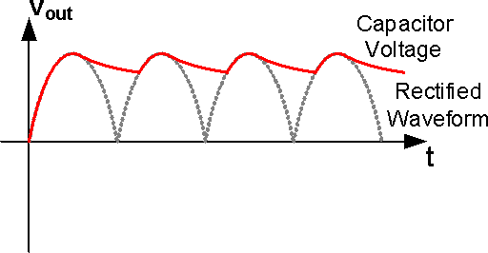

Figure 3 Output Voltage Waveform of the rectifier with capacitor

1. Firstly, one line-to-line voltage is bigger than output voltage and the diodes of the line-to-line is on conduction. Thus, the bridge rectifier supplies a current for both load and filter capacitor. Capacitor voltage is increasing gradually until the output voltage is bigger than input voltages.
2. Secondly, capacitor voltage is bigger than any line-to-line voltages. Thus, all diodes are off and do not let current pass. After this point, capacitor is discharging to supply the load current. Thus, the capacitor voltage is decreasing until the output voltage is smaller than input voltages.

Thus, the rectifier output voltage changes with respect to load current and value of the capacitor and it is not analytically solved to create harmonic decomposition because of nonlinear characteristic.

# State-Space Model

The state space model of the rectifier is created because analytically modelling of the rectifier is hard due to nonlinear characteristic which is mentioned former section.

First of all, 3-phase input is converted to six-pulse voltage waveform and the 6-pulse voltage waveform is given as input to state space model. Secondly, the bridge rectifier is taken as a switch to led the current pass in unidirectional. Thirdly, load current is taken as input because it depends on the load characteristic and the load current is determined by only output voltage and load characteristics. Finally, there are some circuit parameters such as input resistance and inductance of the bridge rectifier and capacitor that creates a state.

New circuit schematic is suitable to apply state-space is shown at Figure 4

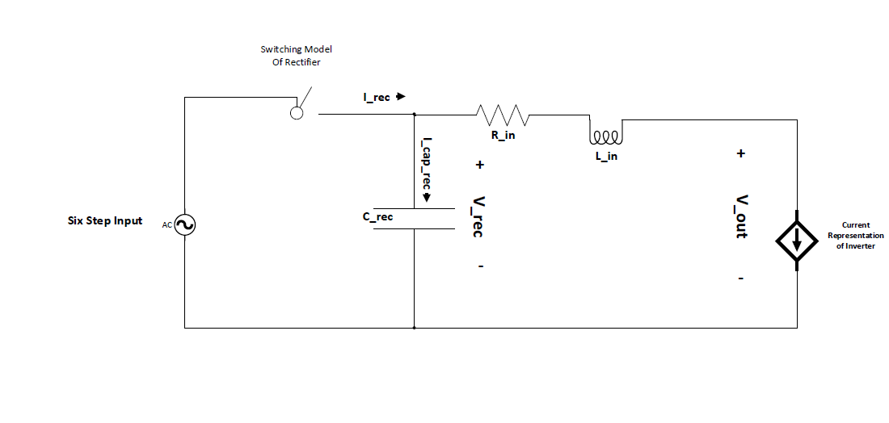

Figure 4 Circuit Schematic for State-Space Model

State Space for discrete systems is represented as:

As rule of thumb, capacitor voltage and inductor current are chosen as state. In the circuit, rectifier capacitor is chosen as state. However, input inductor current is not chosen because it is the same as load current and load current. In the state-space, there are actually 2 equations. One of them for when rectifier supply the load current and other one is when capacitor supply the load current. Which state space is used are controlled by Boolean function by comparing the rectifier and six-step pulse voltage. The flowchart of selection is shown Figure 5

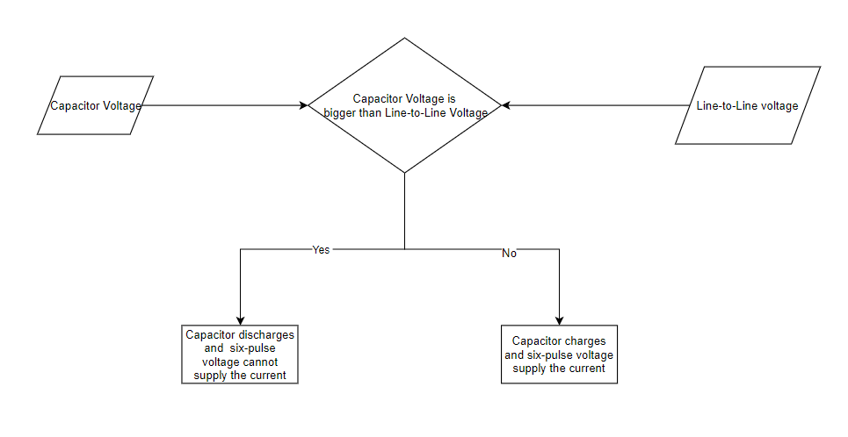

Figure 5 Flow Chart of the mode selection

For first state space model is valid during capacitor is charging:

For second state space model is valid during capacitor is discharging:

For output voltage can be calculated for both condition:

By using these state space model, our system can be thought as two port systems. Thus, we can connect our system to another state space models easily. In other words, constant input voltage and current that is drawn by load determine the output voltage and the output voltage are not linearly dependent to current. Figure 6 shows two port model of rectifier.Figure 6 Two Port Model of Rectifier

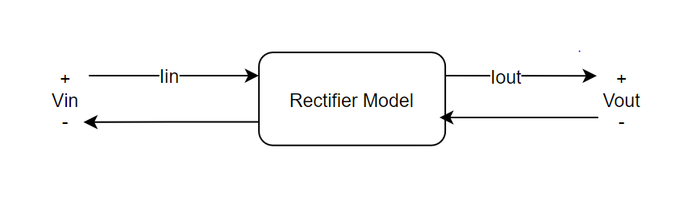

Figure 6 Two Port Model of Rectifier